**MethodsCore**

**FirstLevel Script Documentation**

**09/05/2012**

**Introduction**

The FirstLevel script lets you specify a first level design. The script is as flexible as the SPM GUI, but will save you a lot of time. The FirstLevel Script assumes you’ve already created a MasterData file that describes the trials of your experiment. Once that is done, there are four major sections to fill out:

1. Image and subject information
2. MasterData file and condition information
3. User-specified regressor information
4. Contrast information

Additionally, there is an Advanced Section to the script, which will not be covered in this documentation. There is a brief description of the advanced features in the script itself. If you want to use any of these features, we recommend you contact [MethodsCoreHelp@umich.edu](mailto:MethodsCoreHelp@umich.edu) for information. Filling in these four sections in the script is mostly self-explanatory, and there is extensive help in the script itself. Below we’ll walk you through the steps that require more explanation.

**Visual Tutorials**

There are a series of video tutorials available online. It may be useful to view these while following along in this document.

1 Introduction http://youtu.be/YNl3H8sXgwI?hd=1

2 MasterData File http://youtu.be/Wo2-rTD81vo?hd=1

3 Subjects & Runs http://youtu.be/TfdgtRzezYY?hd=1

4 Conditions, Onsets, & Durations http://youtu.be/X-jkITWrado?hd=1

5 Parametric Regressors http://youtu.be/PcW_IvqY3jM?hd=1

6 User-Specified Regressors http://youtu.be/wRIH_qn3-xE?hd=1

7 Contrasts http://youtu.be/a3r-pwt5jE8?hd=1

8 Conclusion http://youtu.be/BD0mn273wXY?hd=1

**Getting Started**

Copy the FirstLevel_template script from your Methods Core directory into your local experiment directory. This is the file you’ll be editing.

**Part 1: MasterData Files**

A MasterData file is a single CSV file that contains all the information about your experiment. All the information that you would normally specify in the SPM GUI subject-by-subject and condition-by-condition is now specified in a single file. This makes analysis easier, more flexible, and more transparent. You have some flexibility in setting up a MasterData file, but I will describe one way of doing this that you will probably want to follow.

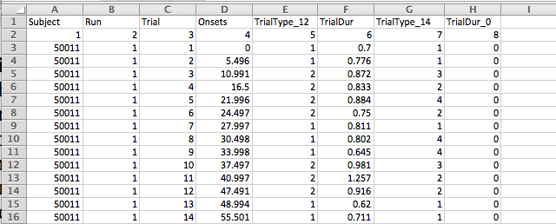

**Figure 1**

Look at Figure 1. I have two header rows here: Row 1 identifies the type of column and row 2 provides the column number (you’ll see why this is useful a bit later). The remaining content of the MasterData file is a trial-by-trial exhaustive list of every trial in the experiment. In the above spreadsheet, I have listed for each trial: the Subject (col 1), Run (col 2), Trial Number (col 3). I also have information for each trial about its Onset, Condition, and Duration but I’ll get to that a bit later.

The MasterData file is one long list. When I get to the end of a run, I start the next run and continue listing trials. The onsets restart because SPM wants to know the onsets relative to the start of a run.

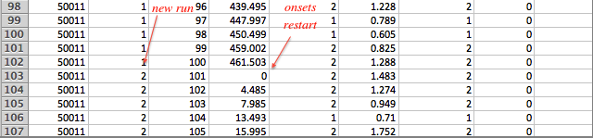

If you start a new subject, then you list the new subject number, and restart run number and trial number (and onsets).

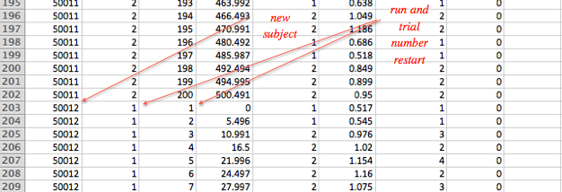

One important note: Other than header rows, there can be only numbers, and no strings, in the MasterData csv file. So give your subjects a numerical ID, at least for MasterData purposes. This has to do with Matlab’s weird way of parsing csv files, and we just have to live with this limitation. Now we can get around this just a bit. The script lets you have not only header rows but also header columns. You set these up by setting the variables below.

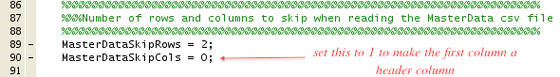

Another important note: Do your CSVs in excel, not Open Office as Open Office

*Conditions, onsets, and durations*

For each trial, we want to be able to assign to it a ***Condition***, an ***Onset***, and a ***Duration***. Recall that for an SPM analysis this information is required for every single trial. Assigning the ***Onset*** and ***Duration*** are easy – they are simply listed in Figure 1 in columns 4 and 6.

The ***Condition*** assignment is done with a numerical method. First, I assign each condition a number starting with 1. So let’s say I have two conditions, Congruent and Incongruent. Then I would assign Congruent as 1 and Incongruent as 2. Next, for each trial, I assign it the appropriate condition using these numbers. For example, in Figure 1, column 5, I assigned every trial a 1 or a 2 based on whether it is Congruent or Incongruent. A bit later, we will ‘point to’ the relevant columns in the MasterData file as we set up our FirstLevel script.

**Part 2: Setting up the FirstLevel_template Script**

You specify a lot of experiment-related information in the FirstLevel script. Most of this should be self-explanatory and there is help in the script itself.

One important issue is setting up paths. You set up the paths to a lot of things (path to functional images, output path, MasterData file, regressor file if you have one, etc…). Setting up paths is done through a standardized ‘Path Template’ system. See the **Path Template Documentation** in the root directory of the Methods Core repository for help on this. We’ll be using this method for setting up paths in pretty much all Methods Core software.

**Setting up Subjects and Runs**

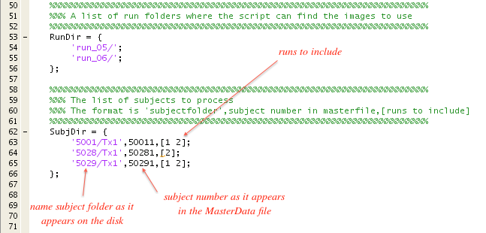

RunDir lists the run names as they appear on the disk. SubjDir lists the subjects to include in the analysis. It has three columns that are explained above. Notice that ‘runs to include’ (i.e., column 3 of SubjDir) indexes the rows of RunDir. So in the above example, we are omitting run_05 for subject 5028 Tx1.

**Setting up conditions, onsets, durations, etc..**

In the FirstLevel_template Script, you ‘point to’ the relevant columns the MasterData file we set up earlier (see Figure 2 below). The script will then ‘find’ the information from the MasterData file. It will go to just the subjects, runs you tell it to, and will ignore the rest. Notice you also name your conditions, and you need to make sure the order of names corresponds to the order of numbers you used in the MasterData File.

But let’s say I change my mind and want to model my data with four conditions: Congruent, Incongruent, Non-response, and Errors. Then I create a new condition column in the MasterData file with the numbers 1 through 4 that represent these conditions. This is column 7 in Figure 1. Then in the FirstLevel script (see Figure 2 below), I replace The CondColumn with 7, and list the new condition names in the ConditionName variable.

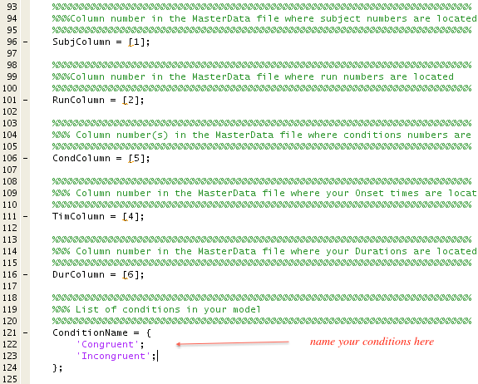

**Figure 2**

**Parametric Regressors**

A parametric regressor is a regressor that modulates activity on a trial-by-trial basis. Adding a parametric regressor is easy. Just add a new column in the MasterData file that specifies the value the parametric regressor takes for each trial.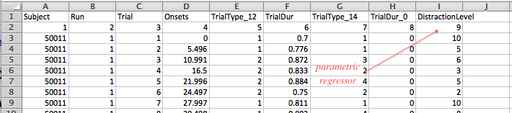

Then you list the name of the parametric regressor and its associated column in the FirstLevel script.

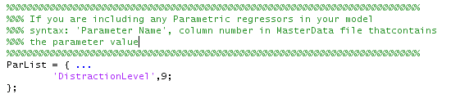

**User-Specified Regressors**

A user-specified regressor (the terminology is from SPM) is a regressor that modulates activity on a scan-by-scan basis. You have two methods for specifying this.

1. Master File Method. Create a new file just like your MasterData file. The difference is the number of rows per subject is not the number of *trials* in the experiment, but rather the number of *scans* in the experiment. Otherwise, it is the same idea. List the regressor values in these rows. In the FirstLevel script, you ‘point to’ the columns of the regressor_MasterData file, and assign names to the regressors, etc…
2. Subject-Specific Motion File Method: The most common scan-by-scan regressors are your motion regressors. So the FirstLevel script lets you specify scan-by-scan regressors by specifying a variable called RegFileTemplates. Each line of RegFileTemplates refers to a single regressor file, followed by a number indicating the number of columns you’d like to use from that file (use Inf to automatically use all the columns). This is followed by a RegDerivatives that lets you choose any or all of the rows of RegFileTemplates to also have first derivative terms calculated for the regressors and also included in your model.

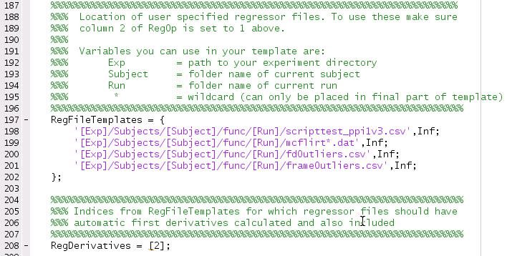

You control which method to use by setting the RegOp variable. You can use either, both, or neither method.

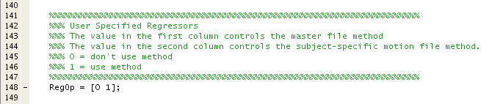

The setting above says don’t use the master file method, but do use the subject-specific motion file method.

**Contrasts**

Let’s say you had an experiment with two conditions, Congruent and Incongruent, and 6 user-specified regressors. Here is what the contrast might look like:

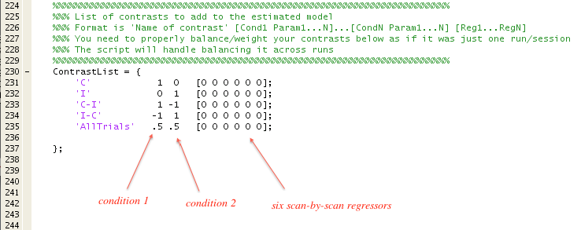

Let’s say you now have 2 conditions and a single parametric regressor, and 6 user-specified regressors. Here is what the contrast might look like.

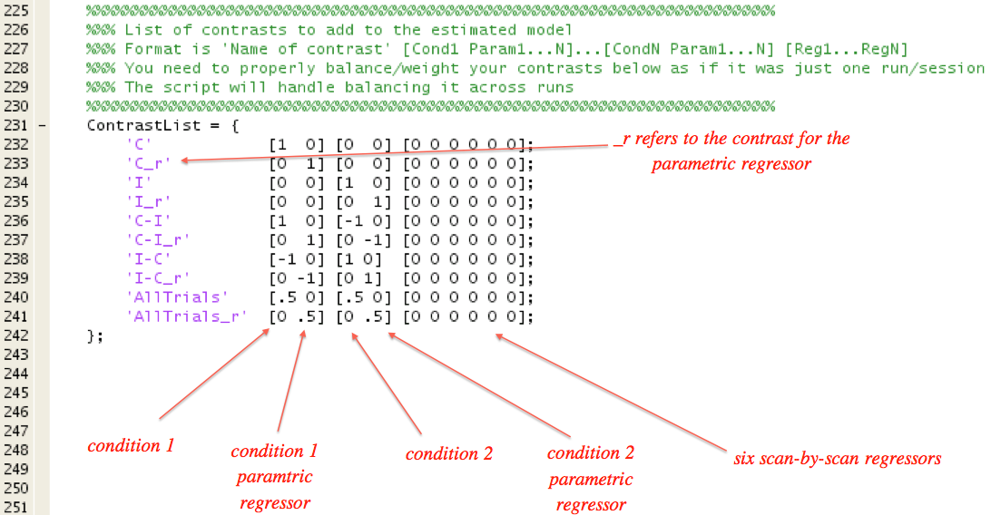

Brackets (i.e., [ and ]) that are placed around the condition/parametric regressor pair and also around the six scan-by-scan regressors are not for cosmetic purposes. The script uses the brackets to parse your ContrastList so do not omit the brackets!

Some other rules to keep in mind are (these are for most standard analyses, and there are exceptions):

* Contrasts against an implicit baseline (e.g., ‘C’) – positive numbers sum to 1, no negative numbers
* Contrasts of two conditions against each other (e.g., ‘I-C’) - positive numbers sum to 1, negative numbers sum to 1

If you follow these rules, your estimated betas will correspond to percent signal change, which is a good thing. The script helps you follow these rules by balancing your numbers across runs. Here is how it works. You specify the contrasts as if there were only one run and you do not include any trailing zeros for the SPM-created run-related regressor. The script will automatically expand/rescale the numbers for the number of runs in your experiment. For example, if there are three runs, all the numbers in the contrasts above would be multiplied by 1/3, and additional trailing zeros for the SPM-created run-related regressors (one per run) would be automatically be created.

To repeat, there is also an Advanced Section, with a LOT of other features. For example, you can have run specific contrasts. You reset SPM defaults. You can drop conditions that appear just a few times. And many others. If you want to use any of these features, we recommend you contact [MethodsCoreHelp@umich.edu](mailto:MethodsCoreHelp@umich.edu) for information.